Unmanned Aerial Vehicle Brain Link Tool Instruction Manual

Created by the Georgia Tech Research Institute

The Unmanned Aerial Vehicle (UAV) Brain Link Tool (BLT) is a program developed by the Georgia Tech Research Institute (GTRI) to allow a user wearing an appropriately configured Emotiv electroencephalogram (EEG) device to send mental commands to and control a UAV.

# User Interface

The UAV BLT runs in the window seen in the following image. Following sections describe each element in the window.

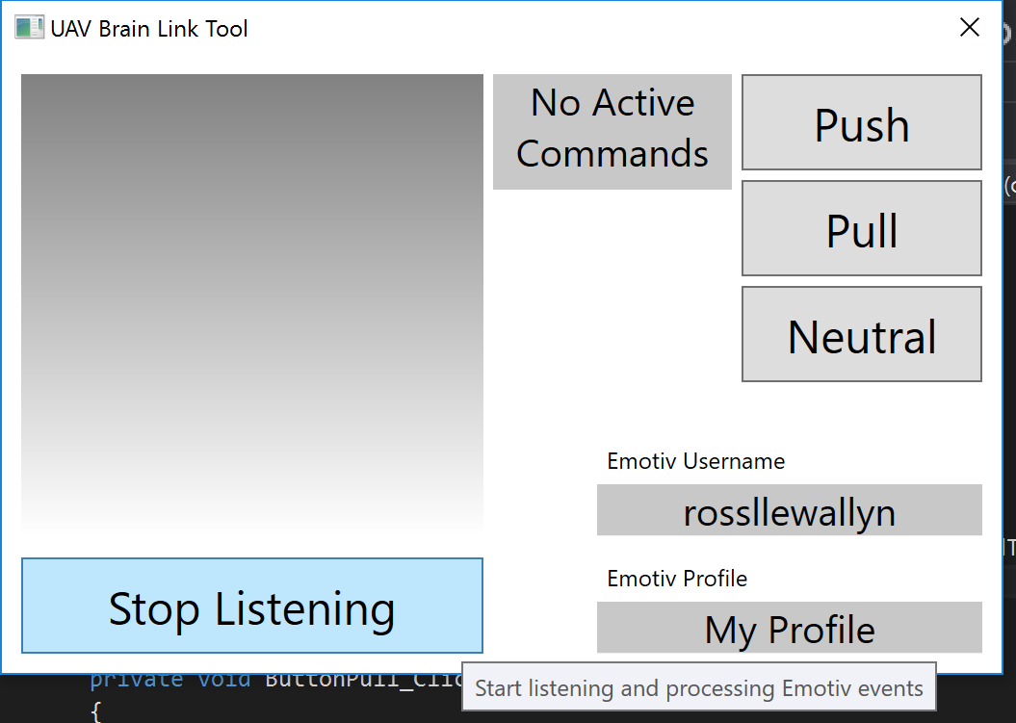

## Graph

In the upper-left of the window, the shaded area will be a graph of emotion information, specifically Stress and Focus, over time.

The graph will contain an upper threshold line for Stress that, when exceeded and listening, will send a Land command to the UAV.

The graph will also contain a lower threshold line for Focus that, when subsumed and listening, will cause commands to not be sent.

## Listening Button

The Listening button toggles between “Start Listening” and “Stop Listening”. It controls whether the BLT is receiving and processing events from the Emotiv device.

This button must be selected (displaying “Stop Listening”) for the program to fully operate.

## Active Commands Display

The grey area in the top middle of the window reading “No Active Commands” displays any commands being sent to the UAV while listening.

## Send Command Buttons

The buttons on the right side of the window are the commands able to be sent to the UAV. Clicking any of them immediately sends that command.

## User Information

The text areas in the bottom right of the window display the Emotiv username and profile. This information, along with a password, is used to access Emotiv servers and obtain the profile to be loaded onto the Emotiv device and used to characterize brain patterns.

# Processing Commands

When the BLT is listening, the Emotiv device turned on, and an appropriate profile loaded, mental commands are sent from the device to the program at a rate of approximately 10 commands per second maximum.

The BLT does not immediately send commands received from the device to the UAV. Received commands are processed through an algorithm to reduce spurious commands or noise.

## Command Processing Algorithm

Received commands from the Emotiv device have a power associated with them. Each command’s power is added to an associated bin (created anew if it is the first command of its kind). Before this addition occurs, however, all bins, including the current command, are decayed based on the time passed since the previously received command (and periodically regardless of received commands).

This decay function is linear and gradually reduces power received to 0 after (by default) 3 seconds if no new commands of its type are received.

# Logging

Actions within the BLT are logged to a directory in the same folder as the program called “Logs”. All received commands, sent commands, toggling of listening, and setup are logged.

# Configuration

The BLT user may adjust many parameters, including the power thresholds for sending commands, emotion thresholds for Stress and Focus, and the decay rate for accumulating commands.